|  |  |  |  |  |  |  |  |  |  |  |  |  |  |  |  |  |  |  |  |  |  |  |  |  |  |  |
| --- | --- | --- | --- | --- | --- | --- | --- | --- | --- | --- | --- | --- | --- | --- | --- | --- | --- | --- | --- | --- | --- | --- | --- | --- | --- | --- |
| |  |  |  |  |  |  |  |  |  |  |  |  |  |  |  |  |  |  |  |  |  |  | | --- | --- | --- | --- | --- | --- | --- | --- | --- | --- | --- | --- | --- | --- | --- | --- | --- | --- | --- | --- | --- | --- | | |  |  | | --- | --- | | For office use only | | | T1 | ________________ | | T2 | ________________ | | T3 | ________________ | | T4 | ________________ | | |  |  | | --- | --- | | For office use only | | | F1 | ________________ | | F2 | ________________ | | F3 | ________________ | | F4 | ________________ | |   **2019**  **22nd Annual High School Mathematical Contest in Modeling (HiMCM) Summary Sheet**  (Please make this the first page of your electronic Solution Paper.)   |  |  | | --- | --- | | **Team Control Number:** | 10103 | | **Problem Chosen:** | A | |

自己论文的Title

从这里开始写摘要内容. 本行文字和下面注意事项内容要删除。全文主要字号设置为小四或12磅，标题字号设置为默认的（标题字号都是大于小四，这是合适的）。

《上面的Team Control Number（控制号）后面的数字改为自己队伍的控制号》

《上面的Problem Chosen填写A或B》《文字颜色都改为黑色》

《正式排版时，删除所有中文注释》

《请谨记：Summary页是没有页眉的喔！》

《不要删除下面的分节符，否则造成页眉不符合比赛规定的格式》

Content

1. Introduction 2

1.1 Question Restatement 2

1.2 Analysis of the Question 2

2. Assumptions and Justifications 2

3. Model 1 2

3.1 Subtitle 2

4. Model 2 3

5. Model x 3

6. Strengths and Weaknesses 3

7. Conclusion 3

References 3

Appendix A ????? 3

Appendix B ????? 3

注意：

本页目录不是必须的(自动更新目录后，需要选中前面目录文本，将其字号设置为“小四”)。

本目录可以在编写过程中查看内容框架，提交论文之前删除本目录。

关于论文正文部分页眉的说明：

1. 首先，不要修改“页码”信息，本word模板可以自己改变（当前页，总页数）；
2. 只需要将Team后面的控制号3333改为自己队的控制号。
3. 总页数也不需要修改——并且总页数不需要计算首页Summary这一页。

# Introduction

As the general awareness of energy and environment conservation across the world, the traditional gasoline-based automobiles are challenged to be the mainstream in the growing favor of battery-electric transportation. Along with those rising electricity demands, some public places “generously” provide “free” charging outlets from the ubiquitous cellphones and laptops to electric vehicles. The problem arises: how to manage the charging sites in various public places and who pays for them? In this paper we present a mathematical model for determining optimal numbers of charging outlets allows for broad-scope types of electric needs. The model includes a plan to depict and predict the energy consumption, a plan to calculate and distribute the resulting costs of those “free” charging outlets for distinctive public places, and a plan to figure out some initiatives in order to deduct those cost expenditures. In addition, we also wrap up a letter to the school newspaper to illustrate our findings and presents our recommendations. We believe our plans are able to bring reliable and scientific suggestion to “free”-charging-installed public places.

## Analysis of the Question

**Q 1:**

As people “plug in” their electric items at the “free” charging sites in public places, what is the influence and what is the requirement for public places to settle the charging sites? Since various public places play their different functions, they construct the charging outlets with diverse purposes. Based on this fact, we define and analyze the impact and requirement with three divided categories:

1. ***Government Sponsor:*** Charging sites served for the daily usage of energy consumption

without required demand.

*Representatives* could be**(a)** ***Library***, **(b)*****School,*** and **(c) *Airport***. In those listed public places, they are not targeted for profit. When installing such “free” charging sites, they target to either satisfy certain ratio of charging demands (Library) or raise the city figure (Airport).

②***Private Sponsor:*** Settling charging sites in order to meet the necessary charging demands.

*Representatives* could be **(a)** ***Offices***. During working time, companies provide their employees with the “free” charging sites in order to let them charge computers to work on files or cellphones to keep contact with clients.

③***Commercial:*** Settling charging sites aimed for attracting potential consumers and increase revenue.

*Representatives* could be**(a)*****Shopping malls*** **(b)*****Coffee shops***. In those commercial and profit-orientated places, their aim is not to need to satisfy all the consumers demand which instead is the maximum revenue.

**Q 2:**

# Assumptions and Justifications

(1) Although free charging outlets in public places exist, considerable amount of people still prefer charging their electric items at home. EVs are great for local driving, as drivers can do most of their charging at home overnight, which is far more convenient than making trips to the gas station. For most owners, 90% or more of charging occurs at home, so use of public charging stations is only occasional. (Tom Saxton & filed under Features, Infrastructure Features.) We consider this ratio between public places and at-home charging as a Constant in our modeling process.

(2) Energy consumptions are generally generated by people who obtains electric items. For instance, electric vehicles like Tesla Motors. More people buy those electric products, more people will be the consumer of those charging outlets, which causes the electric energy consumption. If we collect and analyze the data of electric items sales throughout the past few years, we can deduct the changes of the energy consumption over recent years and predict the future trend. The correlation between the sales of electric items and their energy consumption is what we aimed to work out.

(3) The resulting cost we need to determine must base on our identified demand, which we previously defined as the amount of “free” public charging energy consumption. Moreover, as Question Part Two asked for the resulting costs of such increasing demand, we do not calculate the most efficient energy consumption, which bring the maximum benefit. Instead, we dedicate to the resulting cost of the public charging energy consumption which such demand required.

, estimated energy consumption of EVs (in KWh)

, EV ownership

, average drove miles per EV car

, cost energy per EV car each mile (in KWh)

represents the percentage EV cars charged in public sites.

, represents years.

# Model 1 (Problem 1)

## Introduction to Model 1

In this model, we collect the data of the *past seven years* of *Tesla Motors*. According to those data, we developed a model to determine the fluctuation of the***consumption in Public Electricity Chargers*** over time. To predict EV’s future tendency in a precise result, we use ***polynomial fitting.*** Since we are discussing the increasing tendency of public charging consumption, the increasing in indoor housing outlets’ energy consumption are excluded in this energy consumption calculation.

* + 1. **The Construction of Formula**

From the Financial Report of Tesla Motors, we collect the data from the first sale year to most updated year 2018. We consider the *ownership* and the *energy consumption* by Tesla motors could be converted into the ***public charging energy consumption***. First, we calculate the whole energy consumption of Tesla Motors users. Then, after determining the *public energy charging portion* of Tesla Motors users, we estimated the public charging energy consumption. After obtaining the Using this dataset as base, we calculated the estimated energy consumption of those EVs by the following expression:

## Degree of polynomial fitting

A suitable degree of polynomial fitting is the key to the precise result. In this process, we tried several values of degree to determine which value is the beast match for our dataset.

## Results for Model 1

As we can observe in the graph below, we acquire two most possible results for Model 1. We

***Fig.1.***Results for Model 1

* 1. **Verification for Model 1**

For the fact that we just have seven-year dataset for Tesla motors, our group compare our models with other existing predicted result. If our predicted result has the approximate data result with other accurate predicted model, our model will be confirmed as a valid and reliable tool to predict the future tendency of charging electric products.

According to CNBC analysist and economist Adam Jonas from Morgan Stanley, till 2040, the ownership of Tesla will be 100 times than ownership today. Until the end of 2017, the number of Tesla would be 300,000. For 2018, the fluctuated rate would increase to 80% and the total number of Tesla cars would change to 531,000. Up till 2023, the ownership of Tesla will be 3*10^11. (Adam Jonas) For those past predicted result, we deal with them rationally since there are actual difference between the real number of Tesla motors in 2017 and the predicted number of Tesla motors by CNBC analysist. We express the difference by the graph below:

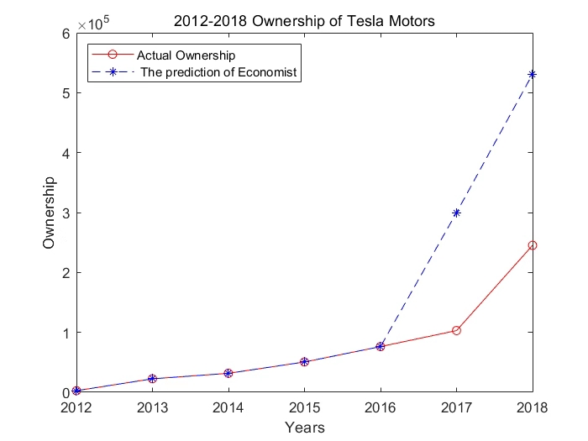

***Fig.2.*** Deviation of Economist’s Data

As we have

1. **Model 2**

## Introduction to Model 2

With *basic economic application* and our *identified impact and requirement*, which is the demand and energy consumption of charging users, our group calculate the resulting cost according to the following expression:

 

Moreover, we consider *two types of electricity device* charging sites when we compute the resulting cost of “free” public charging:

* 1. ***Electric Vehicles***
  2. ***Plug-in***

Based on our previous model, the total cost formula could be described as:

To calculate the , we should calculate and then add the result of and . To this end, we should execute the following procedure step by step:

**Step 1**：Calculate /

**Step 2**：Calculate /

**Step 3**：Calculate /

**Step 4**：Calculate /

**Step 5**：Get result of

As we develop our model, we consider two aspects for the quantity demand of such “free” public charging consumption:

* 1. **: Model 2: EVs Costing Model**
     1. **The construction of the Energy Consumption Formula**

The total energy consumption is the accumulation of energy consumed by every single car. Thus, we first need to calculate the energy of single car. To calculate . Then, we need to identify the quantity demand of “free” public charging. Therefore, we need two possibilities: & and .

In short, Total energy of EVs could be expressed as following:

1. **Probability of Charging Action with Utilization of SOC**

***Firstly,*** no matter for EVs or Plug-in devices, the charging demand, which is the ***possibility of charging action,*** is the factor that need to calculate. It is hard to compute such *varied psychological factor*, but we consider utilizing ***SOC (State of Charge)***. SOC, means the percentage of energy consumption of a car. *For instance*, if SOC of a car equals to 10%, it represents 10% energy of this car battery has been used up (the remaining battery level is 90%). When the SOC decreases to certain value, which we called the ***Minimum Acceptance SOC***, user’s demand begin to raise: they begin to find charging sites to charge for their electric vehicles. Due to the fact that Minimum Acceptance SOC Value varies for each user, users’ demand for charging sites changes as well. Accordingly, not all the users will charge their electric vehicles in the “free” public charging sites and the ratio of their charging demands depends on the calculation of varied minimum SOC acceptance value of each consumer

.

Utilizing SOC to predict the possibility of user’s charging demand, we firstly *fitting* the data a collected by the NHTS2009 (National Household Travel Survey 2009) to determine the possibility of charging demand in diverse public places

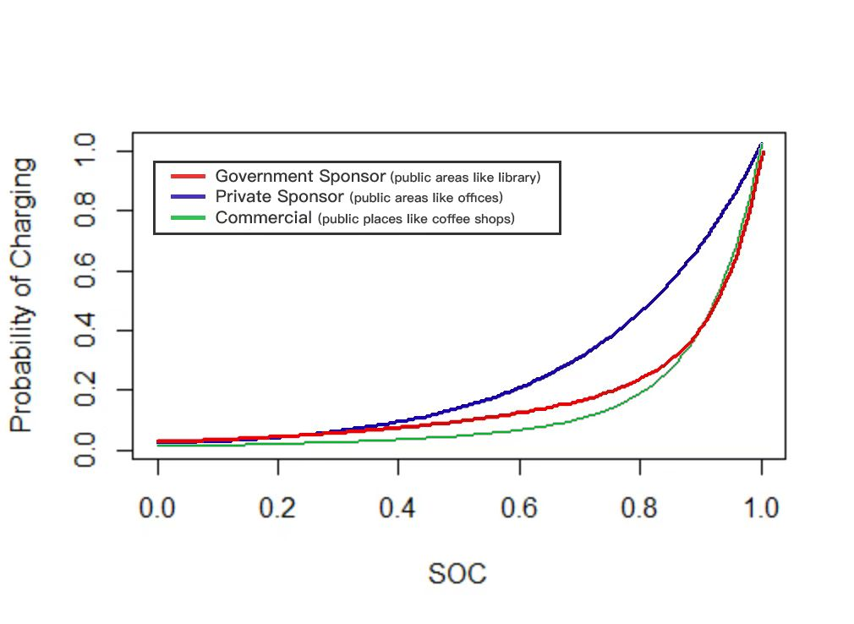

***Fig.3.*** P(x) in different public places

The resulting graph illustrates the relationship between the Minimum Acceptance SOC and the possibility of charging demand in three “free” public charging categories we have defined in part 1.1:

1. ***Government Sponsor*** (public areas like library):
2. ***Private Sponsor*** (public areas like offices):
3. ***Commercial*** (public places like coffee shops):
4. **Probability of Initial SOC Value** .

Then we initiate our ***second step***: compute the ***energy consumption per car.***

According to the EV Project of US of Energy Department, we make the statistics relate to the correlation between the ***frequency*** and ***probability density of Initial SOC***, which is likely to be a normal distribution and defined as .

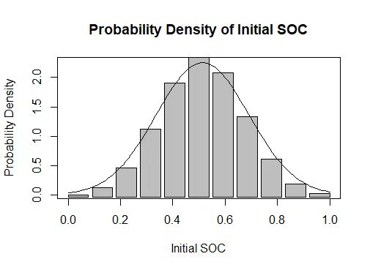

***Fig.4.*** Frequency and probability density of initial SOC

The initial SOC could assist in determining the ***initial battery level*** of a car come for charging in public places. As our assumption for the charging demand to 100% battery level, we can know how much electricity needed for charging to 100% battery level based on the initial battery level is initial SOC.

According to the fitting result, the function for ***Frequency possibility of initial SOC*** is shown below:

1. **Result of Total energy of EVs**

Now the following steps for us is to calculate the which express as:

The demand of users using public places charging sites could be consisted of variables below and form the expression:

Then, we use the times the in order to get the :

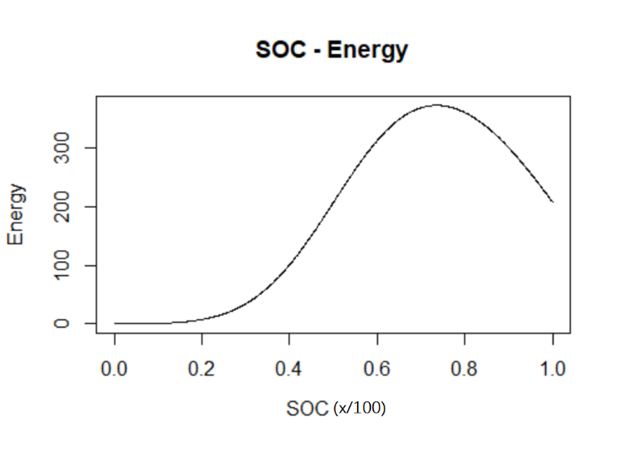

When we compute the formula, we can expand and rewrite it as:

* + 1. **The construction of the Resulting Cost Formula**

As we mentioned before, the Total Cost is composed of two parts:



1. **CE variable**

Since the energy of single EV varies, we utilize the total energy to represent the sum of various and then calculate the ***Variable Cost ()***, which could be expressed as below:

1. **CE fixed**

of *EVs chargers* and the *installation fee* for each charger consist of the ***Fixed Cost* (),** which could be expressed as below:

As we aim to calculate the quantity which satisfy the maximum demand of consumers in “free” public charging places, we adopt the, the maximum Customer Flow to calculate , shown as below:

***Ultimately,*** could be described as:

According to our model, we find how to discover the total cost of EVs.

## Model 3: Plug-In Costing Model

* + 1. **The construction of the Energy Consumption Formula**

In plug-in model, we first calculate the total energy of plug-in charging sites. As same as EVs, we also need to figure out and. For , we need which could be expressed as below:

1. Possibility of plug-in charging

According to the research by LG, when the phone’ s power is less than 20%, people begin to show sign of charging demand. Therefore, the probability that a consumer in a shop need to charge his/her phone is:

In order to get , we collect the data from the graph below(), which shows the daily charging behavior of a person.

***Fig.4 Daily charging behavior*** 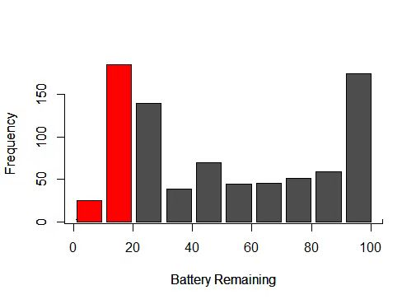

As we can see in the graph above, red part represents the situation of . Thus, we take the percentage of the red part, which occupies 25.21008% of the whole data, as the value we given for .

Then, we draw our attention on energy consumption , Considering the efficiency of charging is not 100%, could be expressed below:

Now we multiply and together to get :

* + 1. **The construction of the Resulting Cost Formula**

As same as the EVs costing model, Plug-in cost also consisted of ***Fixed Cost* ()** and ***Variable Cost ()***.

(I) ***Variable Cost ()***

In order to calculate ***Variable Cost (),*** we need to find out. When we get the amount of energy would be consumed in Plug-in devices, we time the amount with to obtain the total electricity fee. Then, we multiply by days to attain the total cost for Energy consumption. We have our ***Variable Cost*** below:

1. ***Fixed Cost* ()**

What we consider for is to satisfy the maximum quantity demanded. Thus, we choose the apex of the Customer Flow. Once we satisfy the demands when most consumers coming, we satisfy the highest charging demands.

Also, due to fixed cost includes first time installation fee, we also multiply with to get the total ***Fixed Cost.***

***As a result***, we have our Plug-in

## Application of Model 2 + Model 3 (Coffee Shop)

How could our model be used in the reality to actually help computing the cost? To this end, we apply our model to a coffee shop simulation to verify the feasibility and reliability of our model.

* + 1. **Energy consumption for EVs**

1. **Basic information of the coffee shop**
2. From the graph below, we can collect the data for the total C:\Users\new\AppData\Local\Microsoft\Windows\Clipboard\HistoryData\{4A6DB1CE-F2EE-4756-B006-FF75CAD93C0C}\{6DD25EE8-62A3-4F38-869D-44A6B68D2855}\ResourceMap\{406837FD-5A16-4AA2-8812-22B2E7524644}. As we know the portion of people who own EVs in America, we apply this ratio in our coffee shop simulation, assuming 21.6% of all consumers own EVs.

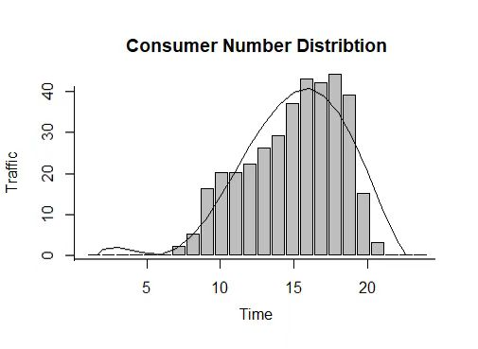

=

***Fig.4 Customer Flow of a Starbuck in Switzerland***

1. According to (), we calculate the **,** approximately ratio of 21.6% for population who own EVs.
2. C:\Users\new\AppData\Local\Microsoft\Windows\Clipboard\HistoryData\{4A6DB1CE-F2EE-4756-B006-FF75CAD93C0C}\{486EF3B1-26A1-42F9-8573-29C2AFEA4890}\ResourceMap\{88060E6A-E778-481F-A759-AFA786FB58E1}Our application demo Coffee shops should be attributed into the Commercial category, which is C:\Users\new\AppData\Local\Microsoft\Windows\Clipboard\HistoryData\{4A6DB1CE-F2EE-4756-B006-FF75CAD93C0C}\{486EF3B1-26A1-42F9-8573-29C2AFEA4890}\ResourceMap\{9DC390AB-CB01-4299-8B71-1122F69687C0}.

Now we put our determined variables into our formula:

Whereas:

Therefore, , which represent the energy cost for charging station. Then, we calculate the cost of the consumption of energy. As shown before,

Considered the situation of coffee bar, we can solve out the number of charging stations:

And for the, we use the American electric charge: F=0.12 dollar/kWh, and for the

the most common charging devices cost: $1,000. Then, solve it out:

**4.4.2 Energy consumption for Plug-in**

When the demand of the plug-in at the highest point, . Therefore, the quantity of plug-in should be at least 44 to satisfied all the consumer’s demand. According to our *cost model for plug in*, the cost of plug-in should be:

**4.4.3: Total cost:**

According to the cost model for plug-in and EV, we gain the *total cost model:*

Whereas 1740 is the fixed cost and 228.63816 is the energy cost per day.

## Extended Application of Model 2 + Model 3 (University)

It will be thoroughly beneficial for all sorts of public places to be sufficiently acknowledged in this aspect: school and offices are able to pay costs by adding to tuition or wages; airports could contain the charge fee in the tickets; sharp-sighted coffee shops and shopping malls can increase their revenue by attracting more consumers with “free” charging initiatives.

1. As they do not gain revenue and we discuss about the “free” charging sites, the

# Model 4 (Problem 4)

# Strengths and Weaknesses

# Conclusion

# References

1. Test
2. Test

## Appendix A ?????

## Appendix B ?????